**Name: Mostafa Mohamed Mohamed Abdelnabe**

**B.N/ 9**

**Date:** 9-6-2021

**Topic:** Database Systems

**Application Brief:**

I chose this topic because data storage for all sites depends on it.

**GitHub-Link:** <https://github.com/mostafa1457/html.project-repository>

**GitHub-Page(Published Website):**

**Screenshots:**

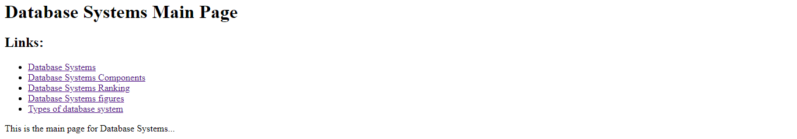

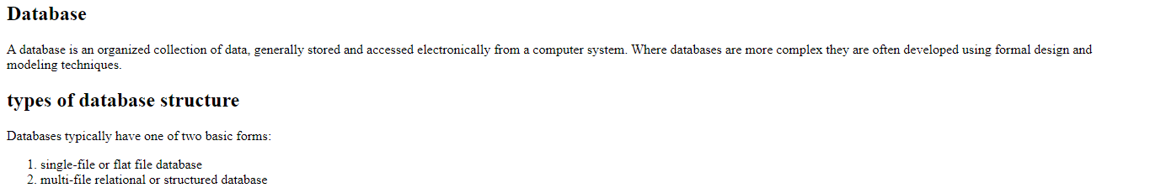



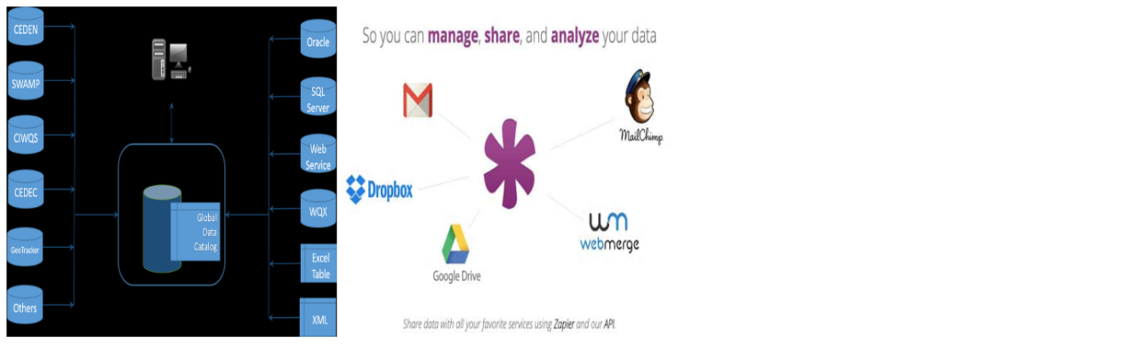

**Source Code:**

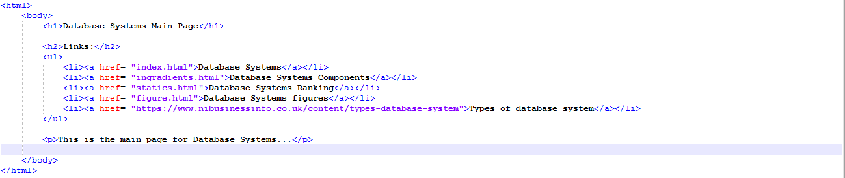

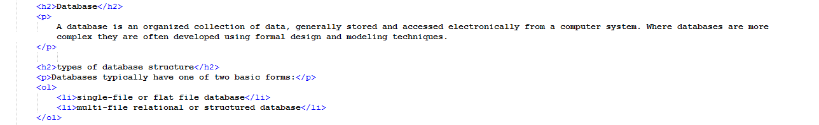

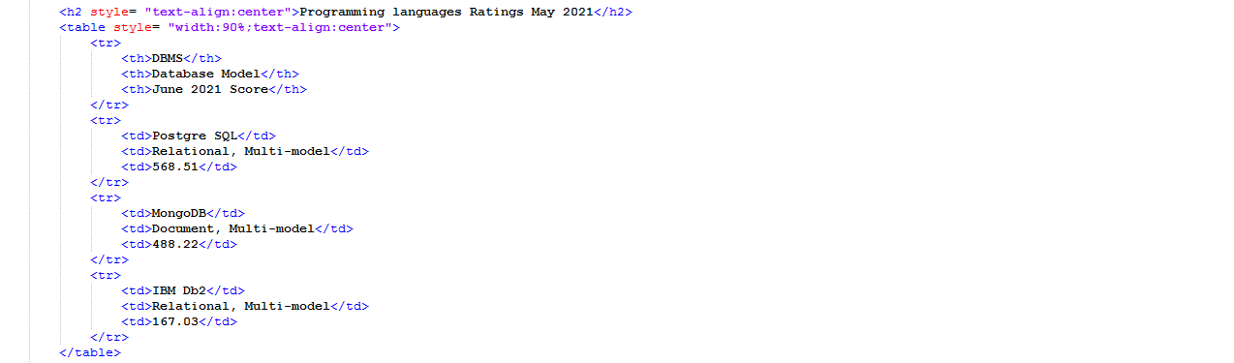

8